**Online Diary**

Summary

An online program for keeping a safe and secure personal diary which can be used by anyone with basic knowledge of computers. The program will help the user in keeping their personal diary entries safe and available everywhere and every time and thus eliminate the need of a paper diary, which also helps in reducing paper usage. The program will be using SQL database to handle data and some GUI so it can be properly used.

Use Case Analysis

The program will start with login screen and have option of recovering password and creating account. After the user logs in, the user will have five options:

1. read entry
2. write entry
3. delete entry
4. delete all entries
5. log out

The create account option will ask for user details and make a new account. The forgot password option will ask for answers to security question and if answered correctly, will show the password.

Data Design

As the program will be using SQL, the following table will be used store a user’s details:

|  |  |  |  |  |  |
| --- | --- | --- | --- | --- | --- |
| Username (key) | Password | Full Name | Security Questions | SQ Answers | Entries |

Another table, which would be created for every user to store diary entries would be like this:

|  |  |
| --- | --- |
| WDate | Entry |

UI Design

The following type of GUI will be used:

1. First Screen: This is what is shown on the first screen

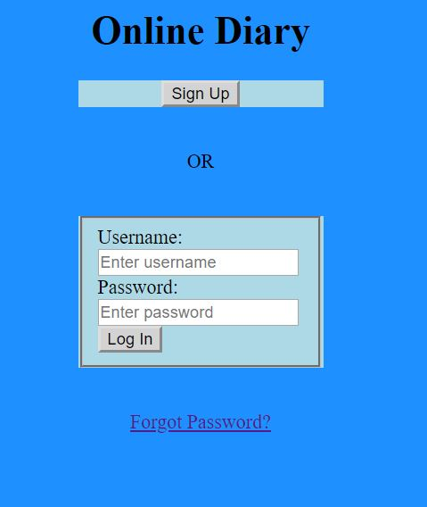

Click on sign up will go to sign up page to create a new account.

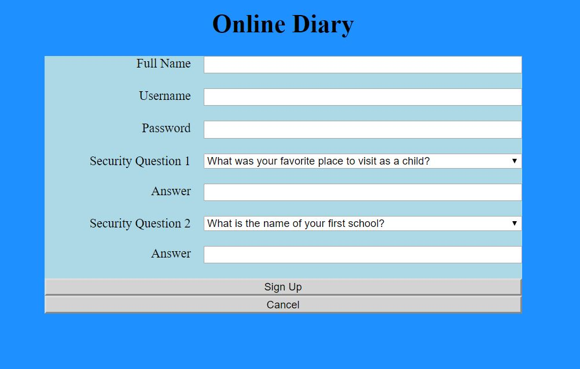

This will create a new account and directly login user

1. After user enter credentials, they will be checked and if incorrect, it would ask user to try again.
2. After Logging In:

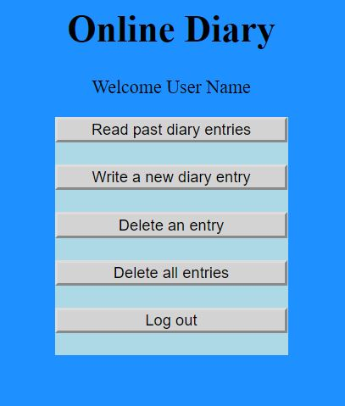

Each button goes to the webpage for the function such as writing diary

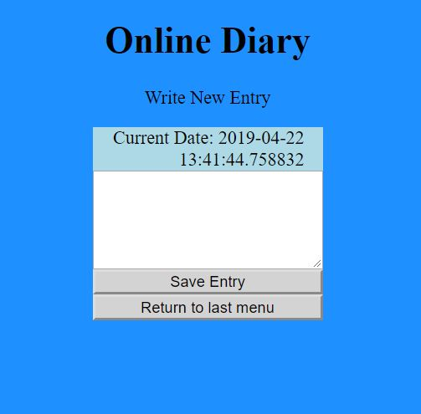

Other screens will have the same architecture, using mostly labels, text entry and buttons.

Algorithm

Create a database file for sql

Create an object for sql that works on the database.

Use <%%> to use python in html files

Get data from user from form

Save in database using sql

Show entries by reading from sql